**Phase1 – Virtual Key for Repositories**

This document contains sections for:

* Sprint planning and Task completion
* Core concepts used in project
* Flow of the Application.
* Demonstrating the product capabilities, appearance, and user interactions.
* Unique Selling Points of the Application
* Conclusions

The code for this project is hosted at https://github.com/NidamanuriRahulKumar/Phase1CoreJavaMainProject.git

The project is developed by **Nidamanuri Rahul Kumar**.

## Sprints planning and Task completion

The project is planned to be completed in 1 sprint. Tasks assumed to be completed in the sprint are:

* Creating the flow of the application
* Initializing git repository to track changes as development progresses.
* Writing the Java program to fulfill the requirements of the project.
* Testing the Java program with different kinds of User input
* Pushing code to GitHub.
* Creating this specification document highlighting application capabilities, appearance, and user interactions.

## **Flow Chart:**

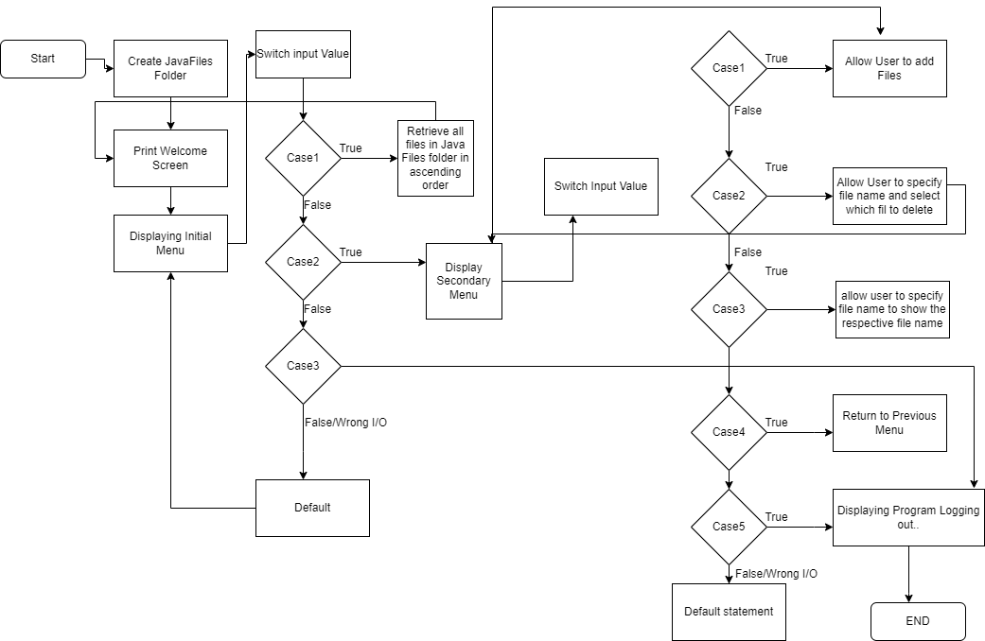

## Demonstrating the product capabilities, appearance, and user interactions

To demonstrate the product capabilities, below are the sub-sections configured to highlight appearance and user interactions for the project:

1. Creating the project in Eclipse
2. Writing a program in Java for the entry point of the application (**MainDef.java**)
3. Writing a program in Java to display Menu options available for the user (**MenuOptions.java**)
4. Writing a program in Java to handle Menu options selected by user (**Controls.java**)
5. Writing a program in Java to perform the File operations as specified by user (**FileOperations.java**)
6. Pushing the code to GitHub repository

## **Step 1:** Creating a new project in Eclipse

* Open Eclipse
* Go to File -> New -> Project -> Java Project -> Next.
* Type in any project name and click on “Finish.”
* Select your project and go to File -> New -> Class.
* Enter **MainDef** in any class name, check the checkbox “public static void main(String[] args)”, and click on “Finish.”

## **Step 2:** Writing a program in Java for the entry point of the application (**MainDef.java**)

package SimpliLearn.Phase1;

public class MainDef{

public static void main(String[] args) {

FileOperations.*createJavaFilesFolderIfNotPresent*("JavaFiles");

MenuOptions.*printWelcomeScreen*("javaProject", "Rahul Kumar N");

Controls.*handleWelcomeScreenInput*();

}

}

## **Step 3:** Writing a program in Java to display Menu options available for the user (**MenuOptions.java**)

* Select your project and go to File -> New -> Class.
* Enter **MenuOptions** in class name and click on “Finish.”

package SimpliLearn.Phase1;

public class MenuOptions {

public static void printWelcomeScreen(String appName, String developerName) {

}

public static void displayMenu() {

String menu = "\n\n>>>>----Select any option number from below and press Enter----<<<<\n\n"

+ "1) Retrieve all files inside \"JavaFiles\" folder\n"

+ "2) Display menu for File operations\n"

+ "3) Exit program\n";

System.*out*.println(menu);

}

public static void displayFileMenuOptions() {

String fileMenu = "\n\n>>>>---- Select an Operation ----<<<<\n\n"

+ "1) Add a file to \"JavaFiles\" folder\n"

+ "2) Delete a file from \"JavaFiles\" folder\n"

+ "3) Search file from \"JavaFiles\" folder\n"

+ "4) Show Previous Menu\n"

+ "5) Exit program\n";

System.*out*.println(fileMenu);

}

}

## **Step 4:** Writing a program in Java to handle Menu options selected by user (**Controls.java**)

* Select your project and go to File -> New -> Class.
* Enter **Controls** in class name and click on “Finish.”

package SimpliLearn.Phase1;

import java.util.List;

import java.util.Scanner;

public class Controls {

public static void handleWelcomeScreenInput() {

boolean running = true;

Scanner sc = new Scanner(System.in);

do {

try {

MenuOptions.displayMenu();

int input = sc.nextInt();

switch (input) {

case 1:

FileOperations.displayAllFiles("JavaFiles");

break;

case 2:

Controls.handleFileMenuOptions();

break;

case 3:

System.out.println("Program exited successfully.");

running = false;

sc.close();

System.exit(0);

break;

default:

System.out.println("Select a valid option");

}

} catch (Exception e) {

System.out.println(e.getClass().getName());

handleWelcomeScreenInput();

}

} while (running == true);

}

public static void handleFileMenuOptions() {

boolean running = true;

Scanner sc = new Scanner(System.in);

do {

try {

MenuOptions.displayFileMenuOptions();

FileOperations.createJavaFilesFolderIfNotPresent("JavaFiles");

int input = sc.nextInt();

switch (input) {

case 1: // File Add

System.out.println("Enter the name of the file to add\"JavaFiles\" folder");

String fileToAdd = sc.next();

FileOperations.createFile(fileToAdd, sc);

break;

case 2: // File/Folder delete

System.out.println("Enter the name of the file to delete \"JavaFiles\" folder");

String fileToDelete = sc.next();

FileOperations.createJavaFilesFolderIfNotPresent("JavaFiles");

List<String> filesToDelete = FileOperations.displayFileLocations(fileToDelete, "JavaFiles");

String deletionPrompt = "\nSelect file to delete" + "\n(Enter 0 if you want to delete all elements)";

System.out.println(deletionPrompt);

int idx = sc.nextInt();

if (idx != 0) {

FileOperations.deleteFileRecursively(filesToDelete.get(idx - 1));

} else {

for (String path : filesToDelete) {

FileOperations.deleteFileRecursively(path);

}

}

break;

case 3:

System.out.println("Enter file name to be searched from \"JavaFiles\" folder");

String fileName = sc.next();

FileOperations.createJavaFilesFolderIfNotPresent("JavaFiles");

FileOperations.displayFileLocations(fileName, "JavaFiles");

break;

case 4:

return;

case 5:

System.out.println(" Logging Out..successfully.");

running = false;

sc.close();

System.exit(0);

default:

System.out.println("select a valid option ");

}

} catch (Exception e) {

System.out.println(e.getClass().getName());

handleFileMenuOptions();

}

} while (running == true);

}

}

## **Step 5:** Writing a program in Java to perform the File operations as specified by user (**FileOperations.java**)

* Select your project and go to File -> New -> Class.
* Enter **FileOperations** in class name and click on “Finish.”

package SimpliLearn.Phase1;

import java.io.File;

import java.io.IOException;

import java.nio.file.Files;

import java.nio.file.Path;

import java.nio.file.Paths;

import java.util.ArrayList;

import java.util.Arrays;

import java.util.Collections;

import java.util.List;

import java.util.Scanner;

import java.util.stream.Collectors;

import java.util.stream.IntStream;

public class FileOperations {

public static void createJavaFilesFolderIfNotPresent(String folderName) {

File file = new File(folderName);

if (!file.exists()) {

file.mkdirs();

}

}

public static void displayAllFiles(String path) {

FileOperations.createJavaFilesFolderIfNotPresent("JavaFiles");

System.out.println("All files in directory path in ascending order\n");

List<String> filesListNames = FileOperations.listFilesInDirectory(path, 0, new ArrayList<String>());

System.out.println("Displaying all files in ascending order\n");

Collections.sort(filesListNames);

filesListNames.stream().forEach(System.out::println);

}

public static List<String> listFilesInDirectory(String path, int indentationCount, List<String> fileListNames) {

File dir = new File(path);

File[] files = dir.listFiles();

List<File> filesList = Arrays.asList(files);

Collections.sort(filesList);

if (files != null && files.length > 0) {

for (File file : filesList) {

System.out.print(" ".repeat(indentationCount * 2));

if (file.isDirectory()) {

System.out.println("`--> " + file.getName());

// Recursively indent and display the files

fileListNames.add(file.getName());

ListFilesInDirectory(file.getAbsolutePath(), indentationCount + 1, fileListNames);

} else {

System.out.println("--> " + file.getName());

fileListNames.add(file.getName());

}

}

} else {

System.out.print(" ".repeat(indentationCount * 2));

System.out.println("-->Directory is empty");

}

System.out.println();

return fileListNames;

}

public static void createFile(String fileToAdd, Scanner sc) {

FileOperations.createJavaFilesFolderIfNotPresent("JavaFiles");

Path pathToFile = Paths.get("./JavaFiles/" + fileToAdd);

try {

Files.createDirectories(pathToFile.getParent());

Files.createFile(pathToFile);

System.out.println(fileToAdd + " created successfully");

System.out.println("Would you like to add some content to the file? (Y/N)");

String choice = sc.next().toLowerCase();

sc.nextLine();

if (choice.equals("y")) {

System.out.println("\n\nInput content and press enter\n");

String content = sc.nextLine();

Files.write(pathToFile, content.getBytes());

System.out.println("\nContent written to file " + fileToAdd);

System.out.println("Content can be read using Notepad or Notepad++");

}

} catch (IOException e) {

System.out.println("Failed to create file " + fileToAdd);

System.out.println(e.getClass().getName());

}

}

public static List<String> displayFileLocations(String fileName, String path) {

List<String> fileListNames = new ArrayList<>();

FileOperations.searchFileRecursively(path, fileName, fileListNames);

if (fileListNames.isEmpty()) {

System.out.println("\n\n>>>>----Couldn't find any file with given file name \"" + fileName + "\" ----<<<<\n\n");

} else {

System.out.println("\n\nFound file at below location(s):");

List<String> files = IntStream.range(0, fileListNames.size())

.mapToObj(index -> (index + 1) + ": " +fileListNames.get(index)).collect(Collectors.toList());

files.forEach(System.out::println);

}

return fileListNames;

}

public static void searchFileRecursively(String path, String fileName, List<String> fileListNames) {

File dir = new File(path);

File[] files = dir.listFiles();

List<File> filesList = Arrays.asList(files);

if (files != null && files.length > 0) {

for (File file : filesList) {

if (file.getName().startsWith(fileName)) {

fileListNames.add(file.getAbsolutePath());

}

if (file.isDirectory()) {

searchFileRecursively(file.getAbsolutePath(), fileName, fileListNames);

}

}

}

}

public static void deleteFileRecursively(String path) {

File currFile = new File(path);

File[] files = currFile.listFiles();

if (files != null && files.length > 0) {

for (File file : files) {

String fileName = file.getName() + " at " + file.getParent();

if (file.isDirectory()) {

deleteFileRecursively(file.getAbsolutePath());

}

if (file.delete()) {

System.out.println(fileName + " deleted successfully");

} else {

System.out.println("Failed to delete " + fileName);

}

}

}

String currFileName = currFile.getName() + " at " + currFile.getParent();

if (currFile.delete()) {

System.out.println(currFileName + " deleted successfully");

} else {

System.out.println("Failed to delete " + currFileName);

}

}

}

**Output’s:**

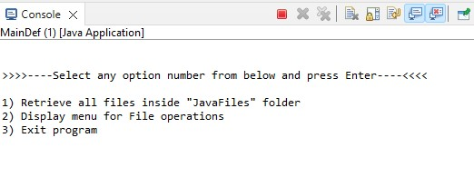

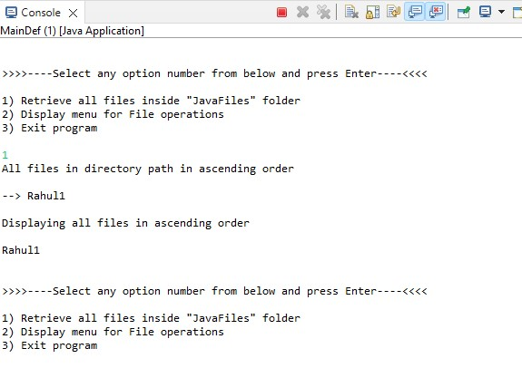

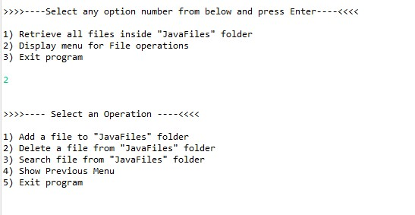

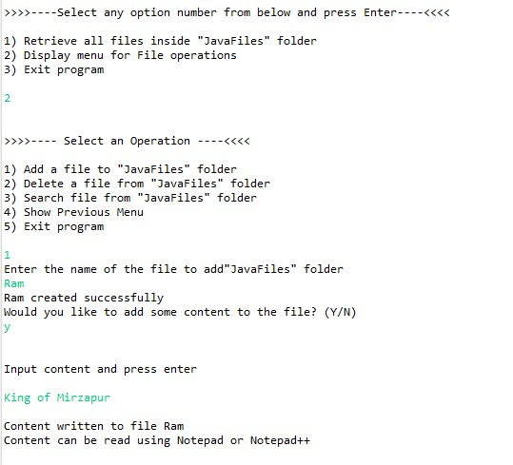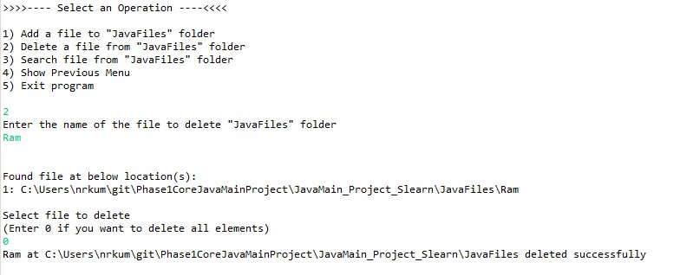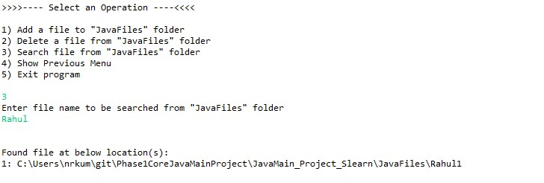

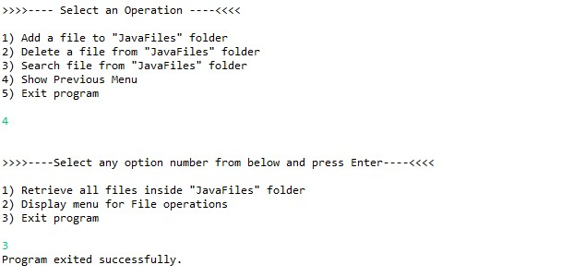

## **Step 6:** Pushing the code to GitHub repository

* Open your command prompt and navigate to the folder where you have created your files.

**cd <folder path>**

* Initialize repository using the following command:

**git init**

* Add all the files to your git repository using the following command:

**git add .**

* Commit the changes using the following command:

**git commit . -m <commit message>**

* Push the files to the folder you initially created using the following command:

**git push -u origin master**

## **Conclusions:**

Further enhancements to the application can be made which may include:

* Conditions to check if user is allowed to delete the file or add the file at the specific locations.
* Asking user to verify if they really want to delete the selected directory if it’s not empty.
* Retrieving files/folders by different criteria like Last Modified, Type, etc.
* Allowing user to append data to the file.